1.

R = {1, 3, 5, 7} and S = {2, 4, 6, 8}. Find R ∪ S.
A.
{ }
B.
{1,2,3,5,6,8}
C.
{1,2,3,4,5,7,8}
D.
{1,2,3,4,5,6,7,8}
E.
{1,2,3,4,5,6,7,8,9,10}

2.

Find the missing members in the set {5, 10, 15, _ , 25, _ , _ ,40}
A.
20 and 30
B.
30 and 35
C.
20 and 35
D.
20, 30 and 35
E.
30, 35 and 45

3.

What property of addition is defined by (a + b)+ c = a + (b + c)?
A.
Union
B.
Inverse
C.
Commutative
D.
Distributive
E.
Associative

4.

Find the highest (greatest) common factor of 63 and 81.
A.
3
B.
7
C.
9
D.
21
E.
27

5.

Change 124_{five} to a base ten numeral.
A.
24
B.
35
C.
39
D.
42
E.
55

6.

Kofi bought 4 books at an average price of ₵2,500.00. If the total cost of 3 of the books was ₵6,500.00, find the cost of the fourth book.
A.
₵3,500.00
B.
₵4,000.00
C.
₵4,500.00
D.
₵6,500.00
E.
₵10,000.00

7.

Find the sum of all even numbers between 70 and 80.
A.
200
B.
223
C.
280
D.
300
E.
375

8.

By how much is
5
6
greater than
3
4
?
A.
1
12
B.
1
6
C.
5
12
D.
2
3
E.
4
5

9.

Evaluate 0.25 x 0.006, correct to three decimal places
A.
0.001
B.
0.002
C.
0.015
D.
0.075
E.
0.105

10.

Express
5
8
as a decimal fraction.
A.
0.125
B.
0.375
C.
0.625
D.
0.750
E.
0.875

11.

The following are the angles formed at the centre of a circle: 30°, 70°, 120°, 2x and 5x. Find the value of x.
A.
20
B.
40
C.
70
D.
100
E.
140

12.

On a map 1 cm represents 4.5 km. What is the actual distance between two towns which are 4 cm apart on the map?
A.
9 km
B.
16 km
C.
18 km
D.
19 km
E.
21 km

13.

If 2y = 6 – 3x, find y when x = 0
A.
–3
B.
–2
C.
0
D.
2
E.
3

14.

How many lines of symmetry has an isosceles triangle?
A.
1
B.
2
C.
3
D.
4
E.
5

15.

Kofi's age in the next ten years will be four times his age five years ago. How old is Kofi now?
A.
5
B.
6
C.
10
D.
15
E.
20

16.

A point P (3, 4) is rotated through an angle of 90° anticlockwise about the origin O.
Find the image P₁ of rotation
A.
(3, -4)
B.
(4, -3)
C.
(-3, 4)
D.
(-4, 3)
E.
(-4, -3)

17.

Which of the following is not quadrilateral?
A.
square
B.
rectangle
C.
rhombus
D.
triangle
E.
parallelogram

18.

Express 2345 in standard form.
A.
2.345 x 10¹
B.
2.345 x 10²
C.
2.345 x 10³
D.
2.345 x 10⁴
E.
2.345 x 10⁵

19.

Solve the inequality 3(x – 1) ≤ 12
A.
x ≤ -5
B.
x ≤ -3
C.
x ≤ 3
D.
x ≤ 5
E.
x ≤
13
3

20.

Kofi and Ama shared an amount of money in the ratio 3 : 2 respectively. If Kofi had ₵60,000.00, how much was shared?
A.
₵36,000.00
B.
₵40,000.00
C.
₵90,000.00
D.
₵100,000.00
E.
₵120,000.00

21.

Workers are required to pay 4
1
2
% of their salaries into an educational fund. A worker’s salary is ₵120,000.00. How much does he pay into the educational fund?
A.
₵5,332.00
B.
₵5,400.00
C.
₵6,000.00
D.
₵10,800.00
E.
₵11,500.00

22.

Araba bought an electric cooker for ₵540,000.00 at a discount of 10%. Find the actual price of the electric cooker.
A.
₵469,000.00
B.
₵496,000.00
C.
₵594,000.00
D.
₵600,000.00
E.
₵605,000.00

23.

Given that
p
2
+
q
2
−
−
−
−
−
−
−
√
= p x q, find the value of a, if a =
13
2
+
15
2
−
−
−
−
−
−
−
−
−
−
√
A.
28
B.
175
C.
195
D.
247
E.
494

24.

A mapping is defined by n → 2n – 3.
What is the image of –2 under the mapping?
A.
–1
B.
–5
C.
–7
D.
7
E.
1

25.

Simplify 4p + 6p² – 2p + 2p²
A.
2p + 8p²
B.
6p + 8p²
C.
2p – 8p²
D.
6p – 8p²
E.
–4 + 10p

26.

Make q the subject of the relation w =
n - q
q
.
A.
q =
n - 1
w
B.
q =
n + 1
w
C.
q =
n + 2
1 + w
D.
q =
n
w + 1
E.
q =
n
w - 1

27.

Given that E =
1
2
mc², find E when m = 10 and c = 4
A.
20
B.
40
C.
60
D.
80
E.
160

28.

Use the information below to answer the question below
The scores obtained by 8 pupils in a test are 2, 3, 4, 5, 7, 8, 8 and 9
What is the median score?
A.
3
B.
5
C.
6
D.
7
E.
8

29.

Use the information below to answer the question below
The scores obtained by 8 pupils in a test are 2, 3, 4, 5, 7, 8, 8 and 9
Find the mean score.
A.
4.50
B.
5.75
C.
6.00
D.
8.75
E.
10.00

30.

Use the information below to answer the question below
The scores obtained by 8 pupils in a test are 2, 3, 4, 5, 7, 8, 8 and 9
What is the probability that a pupil chosen at random scores 8 marks?
A.
1
8
B.
4
23
C.
1
4
D.
1
3
E.
1
2

31.

Use the graph of the straight line below to answer the question below
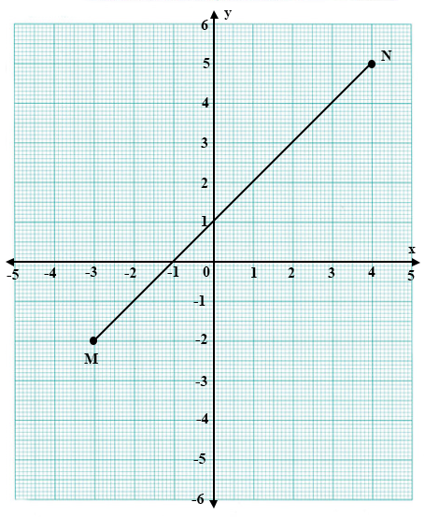
Determine the value of x when y is 3.
A.
1
2
B.
1
1
2
C.
2
D.
3
E.
8

32.

Use the graph of the straight line below to answer the question below
Find the gradient of line MN.
A.
–2
B.
–1
C.
1
D.
3
2
E.
2

33.

State the rule of the following mapping:
x | 1 | 2 | 3 | 4 | 5
↓ | ↓ | ↓ | ↓ | ↓ | ↓
y | 1 | 4 | 9 | 16 | 25
A.
x→x
B.
x→2x
C.
x→3x
D.
x→x²
E.
x→x³

34.

The area of a rectangle is 18 cm² . One of its sides is 9 cm long. Find its perimeter.
A.
11 cm
B.
18 cm
C.
22 cm
D.
36 cm
E.
54 cm

35.

Calculate the area of figure PQRST
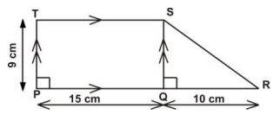
A.
112.5 cm²
B.
135.0 cm²
C.
180.0 cm²
D.
215.0 cm²
E.
315.0 cm²

36.

In an enlargement with scale factor k, which of the following statements is not true?
A.
Each length is multiplied by k
B.
Each angle remains the same
C.
The shape of the figure does not change
D.
The size of the figure does not change
E.
Corresponding lines are parallel

37.

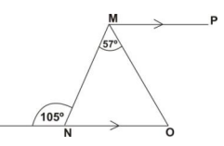
Use the diagram above to answer the question below.
Find the angle MON.
A.
48°
B.
52°
C.
58°
D.
65°
E.
75°

38.

Use the diagram above to answer the question below.
Angle MON and PMO are
A.
Alternate angles
B.
vertically opposite angles
C.
Corresponding angles
D.
adjacent angles
E.
Complementary angles

39.

If u =
(
1
3
)
and v =
(
4
-2
)
, find 2u + 3v.
A.
(
5
1
)
B.
(
11
5
)
C.
(
11
13
)
D.
(
14
0
)
E.
(
14
12
)

40.

Which of the following statements best describes the construction below?
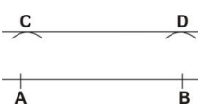
A.
Construction of a horizontal line CD
B.
Construction of a line parallel to AB
C.
Construction of the bisector of AB.
D.
Construction of a top line
E.
Construction of a vertical line.

